North Dakota Soybean Council
(Required for all Research Funding Requests)

  - Non-Technical Summary - Please provide a 250-word summary of proposed research in non-technical terms. Do not duplicate in this section what is presented in the main body of the proposal.
  - Objectives: Using non-technical terms, list measurable objectives that will be accomplished by the research.
  - Project deliverables: List anticipated deliverables of the research.
  - Benefit to North Dakota Soybean Farmers: Highlight why the research should be funded with the soybean check-off and how it will directly benefit North Dakota soybean farmers.

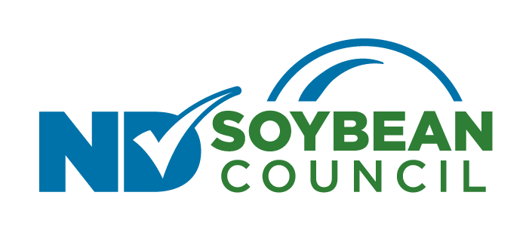

North Dakota Soybean Council
(Required for all Research Funding Requests)
Description of the Proposed Research
Provide a description of the proposed research written in non-technical terms. Provide enough detail so that technical reviewers can make an accurate assessment of the importance and quality of the proposed research. Include the following:

- Brief project justification and rationale: Identify research needs, brief review of similar academic and industry research and how proposed research is necessary, novel, and how it will benefit soybean growers’ overall profitability.
- Brief Description of Proposed Research: Work/experiments to be done including materials and methods needed to achieve the objectives, purpose, expected outcome, contribution to project goal.
- Describe potential barriers to achieving anticipated results: Anticipated problems that could occur which interfere or compromise research.
- Other similar work and funding: Proposed research may complement and extend but must not duplicate already funded research.
- Clear statement of communication and outreach strategies: Describe how research results will be communicated and made available to North Dakota soybean growers.
- Timeline
- Budget justification

